Curriculum Vitae 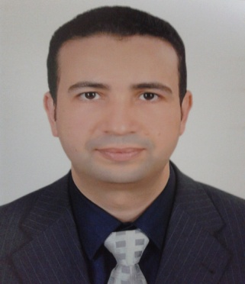

Name : AHMED AHMED SAYED SAYED MOSAAD
Date of birth :1/1/1975
Nationality : Egyptian
Marital status: married &have three children
Permanent address: Kafr taha – Shebin Elknater-Qalubia-Egypt
Telephone NO. :002 01003304881 (Mobile).
Email : drahmedmosaad@yahoo.com
Sex : Male.
Professional qualifications:
Date Establishment Qualification
Aug. -2011 Benha university hospital, Egypt ------- M.D. degree in anesthesia
March-2007 The Saudi Licensing Examination For Health Specialties(anesthesia)
feb.-2006 Benha university hospital, Egypt ------ Master degree in anesthesia

March-2003 Egyptian medical syndicate ------- Registered physician

December-2001 Benha faculty of medicine, Egypt --------- MBBCH
EMPLOYMENT EXPERIENCE
CURRENT APPOINTMENTS:
Lecture of anesthesia and I.C.U in Benha university.
PREVIOUS APPOINTMENTS:
april 2006 TO mars 2011
Full time appointments:
Assistant lecture anesthesia & I.C.U Benha University Hospitals - EGYPT.
mars 2003 TO mars 2006
Full time appointments:
Resident anesthesia & I.C.U Zagazeg University Hospitals -Benha Branch-EGYPT.
From March 2002to February 2003:
Internship appointment (House Officer) anesthesia & i.c.u Zagazeg University Hospitals -Benha Branch Egypt.
RESEARCH & AUDIT
cardiac arrythmias in anesthesia & i.c.u
An essay for fulfillment of the Master Degree in anesthesia & i.c.u Zagazeg University Hospitals -Benha Branch mars 2006.
COMPARTIVE STUDY of neostigmine and ketamine as additivies to plain bupivacaine in caudal analgesia after lower abdominal surrery in pediatrics

Thesis Submitted for fulfillment of the M.D degree in anesthesia and ICU Benha University Hospitals Aug. -2011

REFERENCES:
prof. omr mohi eldin.
Consultant anesthesia& I.C.U benha University HOSPITALS Egypt
Address: benha University HOSPITALS - BENHA CITY .QALUBIA Egypt
Mobile: 00201222170781

prof. MOHAMED HAMDY ELIWA
Consultant anesthesia& I.C.U benha University HOSPITALS Egypt
Address: benha University HOSPITALS - BENHA CITY .QALUBIA Egypt
Mobile: 00201001452351

ASS.prof Ahmed mostafa abdelhamed
Consultant anesthesia& I.C.U benha University HOSPITALS Egypt
Mobile:002 01005204130

